Study visit group report

Group No
Title of the visit | Goals and benefits of co-teaching sciences and philosophy
Topic | Promoting acquisition of key competences throughout the education and training system
City, country | Lyon, France
Type of visit | study visit
Dates of visit | 16.06. 2014 -20.06.2014
Group reporter | Attila Varga

The reporter should submit the report to Cedefop (studyvisits@cedefop.europa.eu) within ONE month of the visit.

I FINDINGS

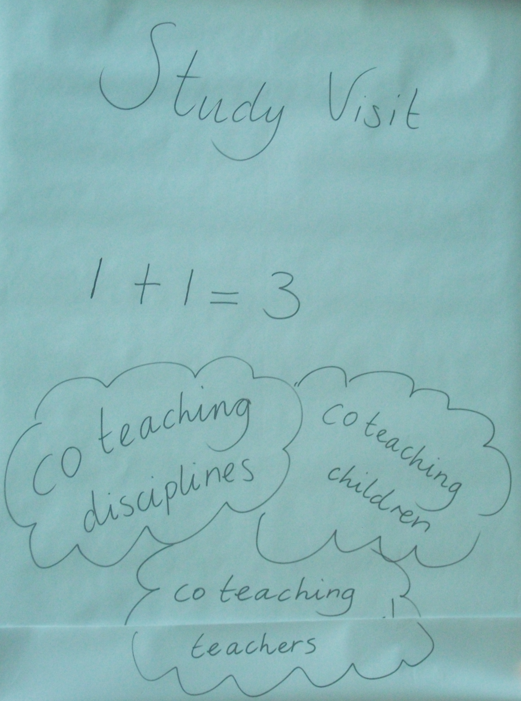

Several approaches of co-teaching exist throughout Europe. All of them are contributions to develop a holistic and meaningful education. The three main types of co-teaching are:

- Co-teaching by different teachers
- Co-teaching different subjects
- Co-teaching different pupils

Co-teaching by different teachers: two or more teachers plan and run together a specific educational session for a group of pupils. The scope of co-operation may vary from a 45 minutes class to two year projects, and from a pair work of teachers to project involved the whole staff of the school and even outside actors as parents, researchers, NGO-s.

Co-teaching different subjects occurs when the aim and content of two or more subjects is taken into consideration while planning and running an educational activity. It is not necessary to imply the co-operation of more than 1 teacher. If a foreign language teacher combines science topics and contents during her teaching that may also be named co-teaching of subjects.

Co-teaching of different pupils: on general level it could refer any educational activities with pupils with different cultural or social background, on more specific level it means activities organized for group of children from different classes of a school or from different schools.

Describe each of the good practices you learnt about during the visit (both from the hosts and from one another) indicating the following:
title of the project/programme/initiative | country | name of the institution that implements it (if possible, provide a website) | contact person (if possible) who presented the programme to the group | whom the project/ programme/ initiative addresses | what features of the project/programme/initiative make it an example of good practice
Full time education for high talented pupils | Netherland | Leonardo onderwijs BasisBuren  www.leonardo-basisburen.nl | Christine Schaafsma | pupils | holistic approach of teaching and special approche of higly gifted children
Co-teaching science with languages | France | Primary school of Limas, Secondary scholl of Meyziu | Philippe Jeanjacquot | pupils | embeding science elements into language classes taking into account science curricula
Coteaching science with philosophy and Maths | France | Primary school of Limas, Secondary scholl of Meyziu | Philippe Jeanjacquot | pupils | co-operative development of combined lessons for science and philosophy and science and mathematics
Co-teaching at master’s level | Isafjordur, Iceland (rural) | University Centre of the Westfjords, www.uwestfjords.is | Dagny Arnarsdottir | students | co-operation of two teacher of different background, e.g. marine biology and social sciences. M
co-teaching in extracurricular activities | Hungary | Hungarian Institute for Educatiional Research and Development | Attila Varga | pupils | using co-ordinated extracurricular activities in order to develop pupils competencies by different co-teaching practises
Computer supported science teaching | Poland | Publiczne Liceum Ogolnoksztalcace  Nr II z Oddzialami Dwujezycznymi, Opole, Poland | Beata Piecuch-Ozarska | pupils | using computer supported learning based on the latest neurological research about the nature of human learning.
* You can describe as many good practices as you find necessary. You can add rows to the table.

  - Approaches taken by participating countries (both host and participants’) regarding the theme of the visit. Are there any similar approaches/measures in participating countries? What aspects are similar and why? What aspects are different and why?

During the study visit following approaches were identified:
- Using science education as contribution to language education
- Making links between subjects
- Introduce ICT supported teaching methods into the traditional way of teaching.
- using extracurricular activities for co-teaching

About similarities and differences among countries: See 2.4.

  - Challenges faced by participating countries (including host) in their efforts to implement policies related to the theme of the visit. What are the challenges? Are they common challenges? If so, why? If not, why not?

The most important common trend described by both organizers and participants is the fragmentation of school work. Fragmentation occurs in different aspects. The content of learning is divided into subjects and time of learning is divided into short lessons (less than one hour). Pupils are divided into classes and often the fragmentation is combined with overburden curricula or very high knowledge expectation of exam systems. The main consequence is an educational work focusing on short term goals (exams, inspector reports) and not reflecting on general question of our life: like ethical values, role of science in modern societies. It is evident that supporting the autonomy of teachers in making decisions on the structure and method of delivery are needed in order to organize the work of schools, but in many cases the structure means only division and there are no efforts to synthesize the work done in different areas of the school life.

Other significant challenge in many European educational systems is the lack of proper teacher education. Teacher education often does not give methodological preparation, proper educational tools for future teachers to realize co-teaching.

  - Name and describe effective and innovative solutions you have identified that participating countries (both host and participants) apply to address the challenges mentioned in question 2.2. Please mention specific country examples.

Primary school in Limas, and secondary school in Meyzieu that we have visited demonstrated well-developed techniques of co-teaching language and science. Both schools use language education not only for a goal in itself but as a mean to communicate with and about our world we are living in. This way of combining science and language education is self-evident.

Another effective solution: Philosophy and astronomy teaching, as presented by Marseille University, was an example of effective teaching approach. Good merger of science and math with historical references, using props (enables students to touch objects and get a better connection, e.g. clay tablet).

- Demonstration of science development.
- Tools given for a real world.
- Learning by touching.
- Using art examples (perspective technology) to explain the math behind the technology.
- Nice demonstration of interconnectedness of culture and science.

Smartphone application (Theodelite) to demonstrate Eratosthenes’ experiment, which was presented during study visit, is a very clear demonstration how new technology could be easily embedded into everyday science teaching.

In Hungary extracurricular activities in the framework of all-day schools provide opportunity for all three approaches co-teaching.

In the Netherlands program for highly talented pupils is organized in a way based on co-teaching approaches.

In Iceland ocean management courses are taught by co-teaching of different teachers.

In Poland computer supported learning methods are used for co-teaching activities. These methods are based on the latest neurological results on the nature of human learning. The knowledge is not readily provided to pupils, but has to be generated by the pupils with the help of their teachers and educational soft-wares.

For contact details of the programs: See: table on Page 3.

  - Assessment of the transferability of policies and practices. Could any examples of good practice presented in this report be applied and transferred to other countries? If so, why? If not, why not?
Participants have reported similar co-teaching initiatives in different countries. Nevertheless there are big differences in the realization of co-teaching approaches depending on the educational system they occur. In some systems co-teaching is hard to realize due to lack of financial resources, in other countries the curricula and the tradition of teaching make it difficult to use co-teaching approaches. The theoretical background and the pedagogical aims of co-teaching is the same in each country, but how to realise them most effectively it is very much different country by county. So international policies and practices could help a lot in teachers’ educational work but successful implementation of the new practices needs local adaptation.

3. Creating networks of experts, building partnerships for future projects is another important objective of the study visit programme.
Participants considered continuing the co-operation in the new Erasmus+ framework by applying to Strategic Partnership projects which provide possibilities for funding of the co-operation. Information about the available support will be circulated among participants.
As the organisers’ and the Hungarian participant’s institution are CIDREE
(Consortium of Institutions of Development and Research of Education in Europe) it has been decided that in order to have possibility to continue the co-operation, the two institutions’ representatives will jointly initiate to integrate the issue of co-teaching into the work plan of CIDREE for 2015.

4. What is the most interesting/useful information that the group believes should be communicated to others? To whom, do you think, this information will be of most interest?

Any type of co-teaching helps to make the educational process more meaningful to pupils. Co-teaching is way to reflect and represent the complexity of reality in the educational practice It highlights the wholeness and interconnectedness of all areas of life. The experiences gained during co-teaching activities prepare pupils to deal with complex often open-ended situations they have to also deal with their later adult life. Teachers must co-operate more and more in order to cope with the continuously changing challenges of our modern world.

Co-teaching increases engagement of all participants of the process, contributes of development of positive self-confidence of pupils and teachers, and making the learning process more joyful.
Co-teaching also involves co-operative learning of students. Co-teaching is also a role model for cooperative learning.

The presented cases during the study visit proved that teachers practising co-teaching could became a model or even a start in their team, and so methods of co-teaching could spread through peer tutoring among teachers.

Use of pedagogical activities without formal evaluation could create fearless climate to pupils. This freedom let the pupils to express themselves realize their new ideas and correct them when necessary.

Combining subjects especially philosophy and science should be embedded into education from the beginning. If young children do not meet opportunities to reflect and ask questions about the process of learning, later they could work more difficulty in groups, and could not develop creative solution for problems they encounter.

II Organisation of the visit

This part of the report will not be published but it will be made available to the organiser and will be used by national agencies and Cedefop to monitor and improve implementation of the study visits programme.

We recognise the value of ongoing feedback as a way of ensuring that the programme is at all times a responsive and dynamic initiative, meeting the needs of its various participants and target audiences. In this section you are invited to give us your feedback on several factors that, in our opinion, contribute to an effective visit.

1. Discuss within the group and check if you agree or disagree with the following statements. Please mark only one box () that expresses most closely the opinion of the entire group. Please use Question 2 of this section to elaborate on your responses, if needed.

 |  | All agree | Most agree | Most disagree | All disagree | Not applicable
e.g. | The size of the group was good.
1.1. | The programme of the visit followed the description in the catalogue. |  | X
1.2. | There was a balance between theoretical and practical sessions. |  | X
1.3. | Presentations and field visits were linked in a coherent and complementary manner. |  | X
1.4. | The topic was presented from the perspectives of the following actors of the education and training system in the host country:
1.4.1. | government and policy-makers |  |  |  |  | X
1.4.2. | social partners |  |  |  |  | x
1.4.3. | heads of institutions |  | x
1.4.4. | teachers and trainers | x
1.4.5. | students/trainees |  |  |  |  | x
1.4.6. | users of services |  |  |  |  | x
1.5. | There was enough time allocated to participants’ presentations. |  | x
1.6. | The background documentation on the theme provided before the visit helped to prepare for the visit. |  |  | x
1.7. | Most of the group received a programme well in advance. |  | x
1.8. | The information provided before the visit about transportation and accommodation was useful. | x
1.9. | The organiser accompanied the group during the entire programme. | x
1.10. | The size of the group was appropriate. | x
1.11. | The group comprised a good mixture of participants with diverse professional backgrounds. | x
1.12. | There were enough opportunities for interaction with representatives of the host organisations. | x
1.13. | There was enough time allocated for discussion within the group. |  | x
1.14. | The Cedefop study visits website provided information that helped to prepare for the visit. |  |  | x

2. If you have any comments on the items 1.1. – 1.14 above, please write them in the box below.

Participants really appreciate the engagement of the organizers and French teachers during the study visit.

It would be very useful to have an opportunity to get in contact with students involved in co-teaching activities to know their experience and opinions.

III Summary

1. Having summarised all your reflections and impressions, please indicate how satisfied you are with your participation in the study visit. Indicate the number of participants for each category, e.g.
Very satisfied | 10

Very satisfied | 6 | Satisfied | 3 | Somewhat satisfied |  | Not satisfied |  | Neither satisfied nor dissatisfied

2. What elements and aspects of the study visits do you think could be changed or improved?

If possible all the materials provided to participants should be translated into working language of the visit.

3. If there is anything else you would like to write about that is not included in the above questions, please feel free to write below or attach a separate sheet.

The study visit was very worthwhile for each participants and all participants express her or his regret about the fact that there will be no possibility to participate in such kind of study visit in the future, and therefore suggest to decision makers to consider to re-establish the possibility to organize expert study visits.
THANK YOU!

Please submit the report to Cedefop (studyvisits@cedefop.europa.eu) within one month of the visit.
Any type of co-teaching helps to make the educational process more meaningful to pupils. Co-teaching is way to reflect and represent the complexity of reality in the educational practice It highlights the wholeness and interconnectedness of all area of life. The experiences gained during co-teaching activities prepare pupils to deal with complex often open-ended situations they have to also deal with late in their adult life. Teachers must co-operate more and more in order to cope with the continuously changing challenges of our modern world.

Co-teaching increases engagement of all participants of the process, contributes of development of positive self-confidence of pupils and teachers, and making the learning process more joyful.

The presented cases during the study visit proved that teachers practising co-teaching could became a model or even a start in their team, and so methods of co-teaching could spread through peer tutoring among teachers.

Combining subjects especially philosophy and science should be embedded into education from the beginning. If young children do not meet opportunities to reflect and ask questions about the process of learning, later they could work more difficulty in groups, and could not develop creative solution for problems they encounter. Any type of co-teaching helps to make the educational process more meaningful to pupils. Co-teaching is way to reflect and represent the complexity of reality in the educational practice It highlights the wholeness and interconnectedness of all area of life. The experiences gained during co-teaching activities prepare pupils to deal with complex often open-ended situations they have to also deal with late in their adult life. Teachers must co-operate more and more in order to cope with the continuously changing challenges of our modern world.

Co-teaching increases engagement of all participants of the process, contributes of development of positive self-confidence of pupils and teachers, and making the learning process more joyful.

The presented cases during the study visit proved that teachers practising co-teaching could became a model or even a start in their team, and so methods of co-teaching could spread through peer tutoring among teachers.

Combining subjects especially philosophy and science should be embedded into education from the beginning. If young children do not meet opportunities to reflect and ask questions about the process of learning, later they could work more difficulty in groups, and could not develop creative solution for problems they encounter.

