Organic Garden final report VC agenda on Jan 23rd, 2010
Total time: 50 minutes
New participants, final report
Taiwan Time 9:00-9:50pm, Jan 23rd, 2010
Event | Person | Time | photos
Brief introduction of the participants & new comers | Cindea---Asia-Pacific coordinator | Taiwan: 9:00-9:02pm  Sat. Jan 23rd  (2 min) | 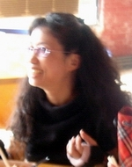
Co-host  Mali Organic garden,  Final report | Sounkalo | Taiwan: 9:02-9:05pm  Bamako 1:02-1:05pm  (3 min) | 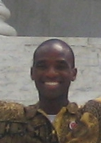
Argentina,  Interpreter,  Copenhagen Parade | Daniel | Taiwan: 9:05-9:07pm  10:04-10:07 am  (2 min) | 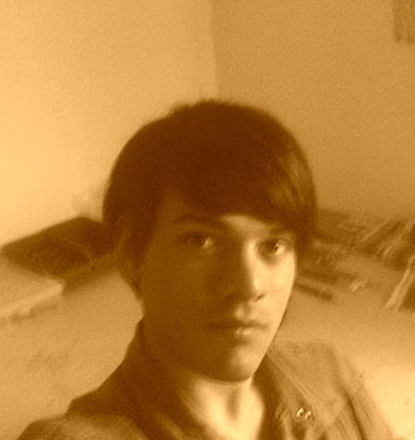
Turkey  Organic Garden | Huri | Taiwan:  9:07-9: 10pm  Istanbul 3:07-3:10pm  (3 min) | 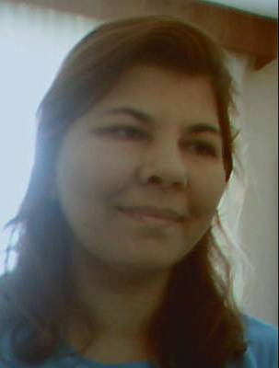
Morocco | Said& Hanane | Taiwan: 9:10-9:15pm  Casablanca  1:10-1:15pm  (5min)
Ruty & Rony  Organic Garden | Ruty& Rony | Taiwan: 9:15-9:17pm  Jerusalem 3:15-3:17pm  (2min) | 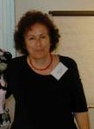
Eric, Charles  France  School introduction | Claude  Eric  Charles | Taiwan: 9:12-9:15pm  Paris 2:12-2:15pm  ( 3 min)
Taiwan Students---  Organic Garden report | Steven& Annika | Taiwan:  9:15-9:20  (5 min)
Colombia  Organic Garden | Rocio&Ana | Taiwan: 9:20-9:25pm  Bogota 8:20-8:25am  (5 min) | 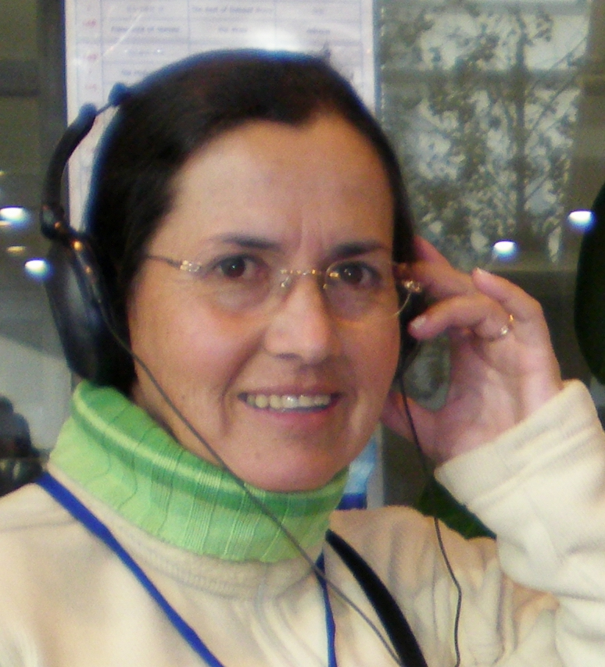
Colombia | Jarold | Taiwan: 9:25pm-9:28pm  Bogota  8:25-8:28am  (3 min) | 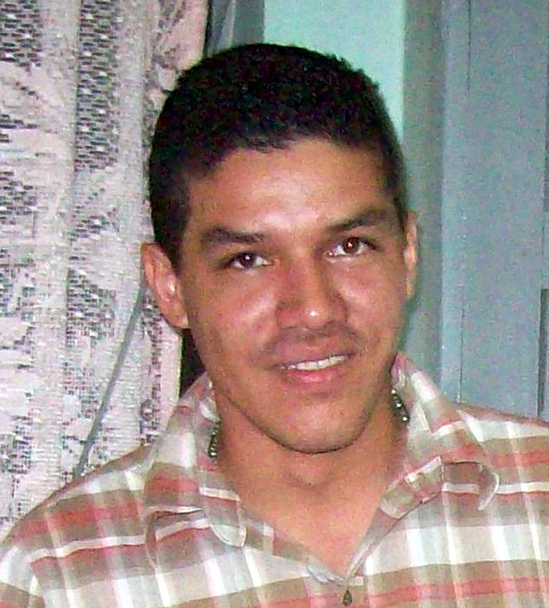
Indonesia | Suparno& Ira | Taiwan:  9:28-9: 30pm  Jakarta: 8:28-8:30pm  (2 min) | 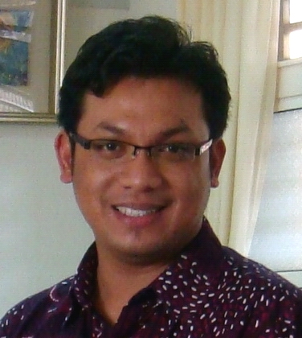
Yoshie from Japan | Yoshie | Taiwan:  9:30-9: 32pm  Tokyo 10:30-10:32pm  (2 min) | 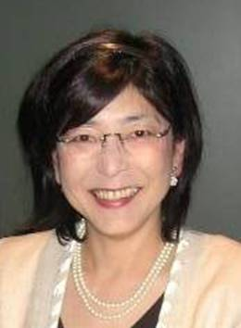
Cindea  Work report After GJC&  Food from the garden | Cindea | Taiwan: 9:32-9:35  (3 min)
Amy from the US | Amy Dwyer | Taiwan: 9:35-9:37pm
Discussion  Q&A | All of the teachers | Taiwan: 9:37-9:50pm  13 minutes

